Lecture#5 Row and Columns
Objectives
- Container and Center Example
- Row
- Column
Example:
Write a flutter code for app given below
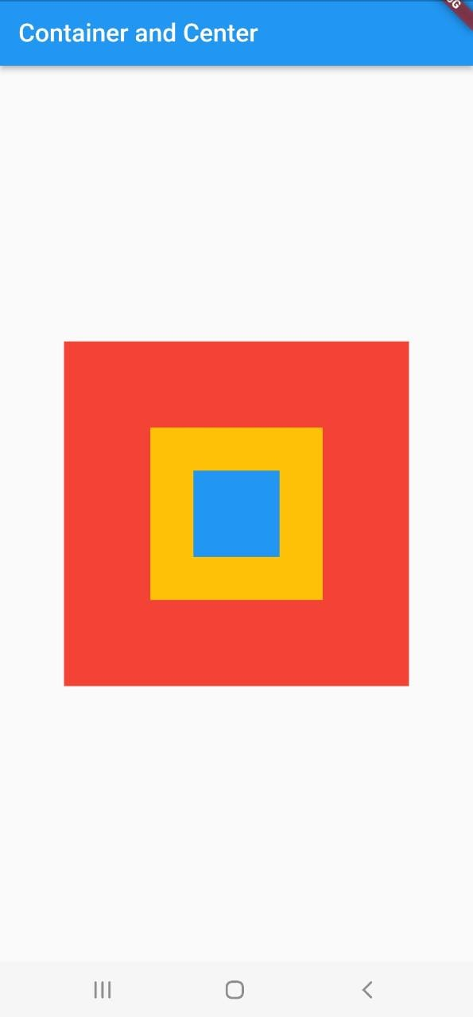
Code:
main.dart
void main() {
runApp(MaterialApp(home:ContainerCenterWidget()));
}

Screen.dart
import 'package:flutter/material.dart';
class ContainerCenterWidget extends StatelessWidget {
@override
Widget build(BuildContext context) {
return Scaffold(
appBar: AppBar(title: Text('Container and Center')),
body: Center(
child: Container(
color: Colors.red,
height: 300,
width:300,
child: Center(
child: Container(
color: Colors.amber,
height: 150,
width: 150,
child:Center(
child: Container(
height: 75,
width: 75,
color: Colors.blue,
),
) ,
),
),
)

),
);

}
}

Row and Column
Row and column are the two essential widgets in Flutter that allows developers to align children horizontally and vertically according to our needs. These widgets are very necessary when we design the application user interface in Flutter.

Key Points
- Row and Column widgets are the most commonly used layout patterns in the Flutter application.
- Both may take several child widgets.
- A child widget can also be a row or column widget.
- We can stretch or constrain a particular children's widget.
- Flutter also allows developers to specify how child widgets can use row and column widgets' available space.

Row Widget
This widget arranges its children in a horizontal direction on the screen. In other words, it will expect child widgets in a horizontal array. If the child widgets need to fill the available horizontal space, we must wrap the children widgets in an Expanded widget. A row widget does not appear scrollable because it displays the widgets within the visible view. So it is considered wrong if we have more children in a row which will not fit in the available space. If we want to make a scrollable list of row widgets, we need to use the ListView widget.
We can control how a row widget aligns its children based on our choice using the property crossAxisAlignment and mainAxisAlignment. The row's cross-axis will run vertically, and the main axis will run horizontally. See the below visual representation to understand it more clearly.
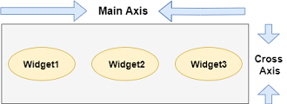
We can align the row's children widget with the help of the following properties:
- start: It will place the children from the starting of the main axis.
- end: It will place the children at the end of the main axis.
- center: It will place the children in the middle of the main axis.
- spaceBetween: It will place the free space between the children evenly.
- spaceAround: It will place the free space between the children evenly and half of that space before and after the first and last children widget.
- spaceEvenly: It will place the free space between the children evenly and before and after the first and last children widget.
Example:
import 'package:flutter/material.dart';

void main() { runApp(MyApp()); }
class MyApp extends StatelessWidget {
@override
Widget build(BuildContext context) {
return MaterialApp(
home: MyHomePage()
);
}
}

class MyHomePage extends StatefulWidget {
@override
_MyHomePageState createState() => _MyHomePageState();
}

class _MyHomePageState extends State<MyHomePage> {
@override
Widget build(BuildContext context) {
return Scaffold(
appBar: AppBar(
title: Text("Flutter Row Example"),
),
body: Row(
mainAxisAlignment: MainAxisAlignment.spaceEvenly,
children:<Widget>[
Container(
margin: EdgeInsets.all(12.0),
padding: EdgeInsets.all(8.0),
decoration:BoxDecoration(
borderRadius:BorderRadius.circular(8),
color:Colors.green
),
child: Text("React.js",style: TextStyle(color:Colors.yellowAccent,fontSize:25),),
),
Container(
margin: EdgeInsets.all(15.0),
padding: EdgeInsets.all(8.0),
decoration:BoxDecoration(
borderRadius:BorderRadius.circular(8),
color:Colors.green
),
child: Text("Flutter",style: TextStyle(color:Colors.yellowAccent,fontSize:25),),
),
Container(
margin: EdgeInsets.all(12.0),
padding: EdgeInsets.all(8.0),
decoration:BoxDecoration(
borderRadius:BorderRadius.circular(8),
color:Colors.green
),
child: Text("MySQL",style: TextStyle(color:Colors.yellowAccent,fontSize:25),),
)
]
),
);
}
}
Output:
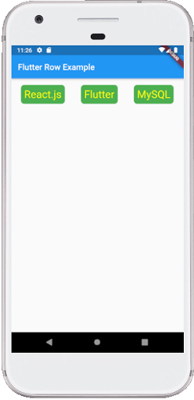

Column
This widget arranges its children in a vertical direction on the screen. In other words, it will expect a vertical array of children widgets. If the child widgets need to fill the available vertical space, we must wrap the children widgets in an Expanded widget.
A column widget does not appear scrollable because it displays the widgets within the visible view. So it is considered wrong if we have more children in a column which will not fit in the available space. If we want to make a scrollable list of column widgets, we need to use the ListView Widget.
We can also control how a column widget aligns its children using the property mainAxisAlignment and crossAxisAlignment. The column's cross-axis will run horizontally, and the main axis will run vertically. The below visual representation explains it more clearly.
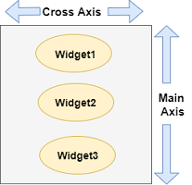

Code:
class MyHomePage extends StatefulWidget {
@override
_MyHomePageState createState() => _MyHomePageState();
}

class _MyHomePageState extends State<MyHomePage> {
@override
Widget build(BuildContext context) {
return Scaffold(
appBar: AppBar(
title: Text("Flutter Column Example"),
),
body: Column(
mainAxisAlignment: MainAxisAlignment.spaceBetween,
children:<Widget>[
Container(
margin: EdgeInsets.all(20.0),
padding: EdgeInsets.all(12.0),
decoration:BoxDecoration(
borderRadius:BorderRadius.circular(8),
color:Colors.red
),
child: Text("React.js",style: TextStyle(color:Colors.yellowAccent,fontSize:20),),
),
Container(
margin: EdgeInsets.all(20.0),
padding: EdgeInsets.all(12.0),
decoration:BoxDecoration(
borderRadius:BorderRadius.circular(8),
color:Colors.red
),
child: Text("Flutter",style: TextStyle(color:Colors.yellowAccent,fontSize:20),),
),
Container(
margin: EdgeInsets.all(20.0),
padding: EdgeInsets.all(12.0),
decoration:BoxDecoration(
borderRadius:BorderRadius.circular(8),
color:Colors.red
),
child: Text("MySQL",style: TextStyle(color:Colors.yellowAccent,fontSize:20),),
)
]
),
);
}
}
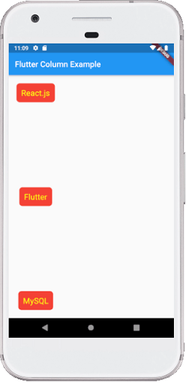

Drawbacks OF Row and Column Widget:
- Row widget in Flutter does not have horizontal scrolling. So if we have inserted a large number of children in a single row that cannot be fit in that row, we will see the Overflow message.
- Column widget in Flutter does not have vertical scrolling. So if we have inserted a large number of children in a single column whose total children size is not equal to the height of the screen, we will see the Overflow message.

Lecture#6 Text Form Field
Objectives
- Text Form Field
- Elevated Button
- Calculator Example (Stateless)
- Calculator Example (Stateful)
Text Form Field
Constructor:
TextFormField({
Key? key,
this.controller,
String? initialValue,
FocusNode? focusNode,
InputDecoration? decoration = const InputDecoration(),
TextInputType? keyboardType,
TextCapitalization textCapitalization = TextCapitalization.none,
TextInputAction? textInputAction,
TextStyle? style,
StrutStyle? strutStyle,
TextDirection? textDirection,
TextAlign textAlign = TextAlign.start,
TextAlignVertical? textAlignVertical,
bool autofocus = false,
bool readOnly = false,
ToolbarOptions? toolbarOptions,
bool? showCursor,
String obscuringCharacter = '•',
bool obscureText = false,
bool autocorrect = true,
SmartDashesType? smartDashesType,
SmartQuotesType? smartQuotesType,
bool enableSuggestions = true,
MaxLengthEnforcement? maxLengthEnforcement,
int? maxLines = 1,
int? minLines,
bool expands = false,
int? maxLength,
ValueChanged<String>? onChanged,
GestureTapCallback? onTap,
VoidCallback? onEditingComplete,
ValueChanged<String>? onFieldSubmitted,
FormFieldSetter<String>? onSaved,
FormFieldValidator<String>? validator,
List<TextInputFormatter>? inputFormatters,
bool? enabled,
double cursorWidth = 2.0,
double? cursorHeight,
Radius? cursorRadius,
Color? cursorColor,
Brightness? keyboardAppearance,
EdgeInsets scrollPadding = const EdgeInsets.all(20.0),
bool? enableInteractiveSelection,
TextSelectionControls? selectionControls,
InputCounterWidgetBuilder? buildCounter,
ScrollPhysics? scrollPhysics,
Iterable<String>? autofillHints,
AutovalidateMode? autovalidateMode,
ScrollController? scrollController,
String? restorationId,
bool enableIMEPersonalizedLearning = true,
MouseCursor? mouseCursor,
})

In this lecture we shall be discussing about two important attributes decoration and controller.
Code
TextFormField(
decoration: InputDecoration(
hintText: 'Enter Name',
labelText: 'Provide Name',
border: OutlineInputBorder(
borderRadius: BorderRadius.all(Radius.circular(4.5))
)
),

)
Output:
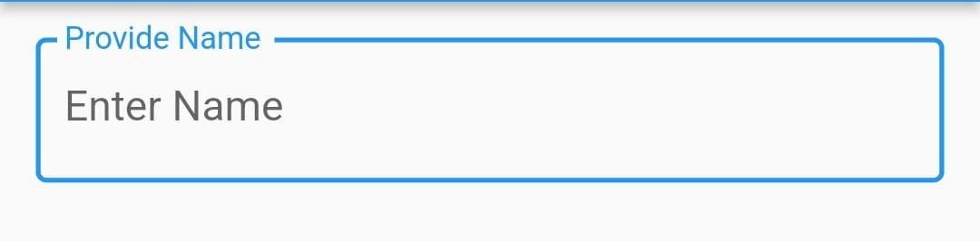

Controller property requires object of TextEdittingController class. Declare object at class level. Value can be get or set using controller.
Code
// declare at class level
TextEditingController namecontroller = TextEditingController();

TextFormField(
controller: namecontroller,
decoration: InputDecoration(
hintText: 'Enter Name',
labelText: 'Provide Name',
border: OutlineInputBorder(
borderRadius: BorderRadius.all(Radius.circular(4.5))
)
),

)

// assign Ali to TextFormField
namecontroller.text='Ali';
// will assign data entered in TextForField in variable name
String name= namecontroller.text;
Elevated Button Widget
Constructor
ElevatedButton({
Key? key,
required VoidCallback? onPressed,
VoidCallback? onLongPress,
ValueChanged<bool>? onHover,
ValueChanged<bool>? onFocusChange,
ButtonStyle? style,
FocusNode? focusNode,
bool autofocus = false,
Clip clipBehavior = Clip.none,
required Widget? child,
})
Important Properties
- onPressed
- child
- style
ElevatedButton(onPressed: add, child: Text("ADD")),
onPressed requires a function to be called when button is pressed. You can create anonymous function as well.
child requires a widget in above case child of elevated button is Text with value ADD. button will appear with fore text as ADD
Calculator Example using Stateless Widget
Requirement
- Will have three text fields (two fields for input and one for showing result)
- 4 buttons for add, subtract, multiply and divide.
- On clicking each button relevant functionality will be performed
Code:
import 'package:flutter/cupertino.dart';
import 'package:flutter/material.dart';

class CalculatorPage extends StatelessWidget
{
TextEditingController number1=TextEditingController();
TextEditingController number2=TextEditingController();
TextEditingController result=TextEditingController();
void add()
{
int n1=int.parse(number1.text);
int n2=int.parse(number2.text);
int res=n1+n2;
result.text=res.toString();

}
void divide()
{
int n1=int.parse(number1.text);
int n2=int.parse(number2.text);
double res=n1/n2;
result.text=res.toString();

}
void multiply()
{
int n1=int.parse(number1.text);
int n2=int.parse(number2.text);
int res=n1*n2;
result.text=res.toString();

}

@override
Widget build(BuildContext context) {
return Container(color: Colors.grey,
padding: EdgeInsets.all(20.0),
child: Column(

children: [
TextFormField(controller: number1,
style: TextStyle(fontSize: 30),
decoration: InputDecoration(
hintText: "Enter Number 1",
labelText: "Number 1",
border: OutlineInputBorder(
borderRadius: BorderRadius.all(Radius.circular(10.0))
)

),

),
SizedBox(height: 20,),
TextFormField(
style: TextStyle(fontSize: 30),
decoration: InputDecoration(
hintText: "Enter Number 2",
labelText: "Number 2",
border: OutlineInputBorder(
borderRadius: BorderRadius.all(Radius.circular(10.0))
)

),
controller: number2,),
SizedBox(height: 20,),
TextFormField(
style: TextStyle(fontSize: 30),
readOnly: true,
decoration: InputDecoration(
hintText: "Answer",
labelText: "Answer",
border: OutlineInputBorder(
borderRadius: BorderRadius.all(Radius.circular(10.0))
)

),
controller: result,),
SizedBox(height: 20,),
Row(
children: [
ElevatedButton(
style: ButtonStyle(
textStyle: MaterialStateProperty.all(TextStyle(fontSize: 15)),
backgroundColor: MaterialStateProperty.all(Colors.white),
foregroundColor: MaterialStateProperty.all(Colors.black),
elevation: MaterialStateProperty.all(30.0)
),
onPressed: add, child: Text("ADD")),
SizedBox(width: 10,),
ElevatedButton(
style: ButtonStyle(
textStyle: MaterialStateProperty.all(TextStyle(fontSize: 15)),
backgroundColor: MaterialStateProperty.all(Colors.white),
foregroundColor: MaterialStateProperty.all(Colors.black),
elevation: MaterialStateProperty.all(30.0)
),
onPressed:(){
int n1=int.parse(number1.text);
int n2=int.parse(number2.text);
int res=n1-n2;
result.text=res.toString();
}, child: Text("Subtract")),
SizedBox(width: 10,),
ElevatedButton(
style: ButtonStyle(
textStyle: MaterialStateProperty.all(TextStyle(fontSize: 15)),
backgroundColor: MaterialStateProperty.all(Colors.white),
foregroundColor: MaterialStateProperty.all(Colors.black),
elevation: MaterialStateProperty.all(10.0)
),
onPressed:divide, child: Text("Divide")),
SizedBox(width: 10,),
ElevatedButton(
style: ButtonStyle(
textStyle: MaterialStateProperty.all(TextStyle(fontSize:15)),
backgroundColor: MaterialStateProperty.all(Colors.white),
foregroundColor: MaterialStateProperty.all(Colors.black),
elevation: MaterialStateProperty.all(30.0)
),
onPressed:multiply, child: Text("Multiply"))

],
)

],
),

);
}

}
Output:
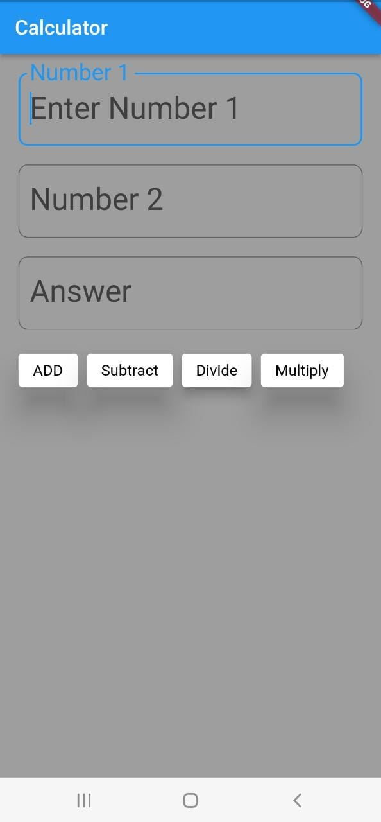
What if we want to store data on label (Text widget). Text widget is a stateless widget. What if we want to assign result to a Text widget. We will have to refresh our widgets which is not possible in case of stateless widget. We have to create stateful widget that enables us to refresh the widget. Stateful widget requires management of it’s state we require two classes 1 a widget and other class maintaining it’s state.
Following approaches are used for state management.
- Provider
- Riverpod
- setState
- Redux
- Fish-Redux
- Bloc/Rx
- Getlt
- Mobx
- Binder
- GetX
- states_rebuilder
- Triple Pattern
In this lecture we will discuss only about setState. setState is used to call the build the method. setState is call inside stateful widgets.
Consider Following Screen
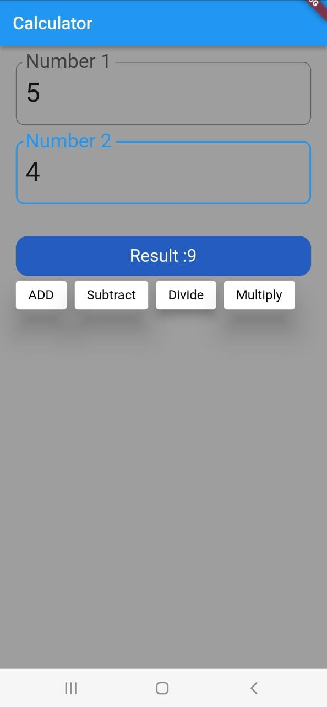 | App consist of  - Two Text Form Fields  - Text (for displaying answer)  - Buttons  On clicking a button answer is computed and displayed on a Text (label).  This app will be developed using stateful widget.
Code:
import 'package:flutter/cupertino.dart';
import 'package:flutter/material.dart';

class CalculatorPage extends StatefulWidget
{
@override
State<CalculatorPage> createState() => _CalculatorPageState();
}

class _CalculatorPageState extends State<CalculatorPage> {
TextEditingController number1=TextEditingController();

TextEditingController number2=TextEditingController();

TextEditingController result=TextEditingController();

String answer="Result: ";

void add()
{
int n1=int.parse(number1.text);
int n2=int.parse(number2.text);
int res=n1+n2;
setState(() {
answer="Result :"+ res.toString();
});
}
void divide()
{
int n1=int.parse(number1.text);
int n2=int.parse(number2.text);
double res=n1/n2;
setState(() {
answer="Result :"+ res.toString();
});
}
void multiply()
{
int n1=int.parse(number1.text);
int n2=int.parse(number2.text);
int res=n1*n2;
result.text=res.toString();
setState(() {
answer="Result :"+ result.text;
});

}

@override
Widget build(BuildContext context) {

return Container(color: Colors.grey,
padding: EdgeInsets.all(20.0),
child: Column(
mainAxisAlignment: MainAxisAlignment.start,
crossAxisAlignment: CrossAxisAlignment.start,

children: [
TextFormField(controller: number1,
style: TextStyle(fontSize: 30),
decoration: InputDecoration(
hintText: "Enter Number 1",
labelText: "Number 1",
border: OutlineInputBorder(
borderRadius: BorderRadius.all(Radius.circular(10.0))
)

),

),
SizedBox(height: 20,),
TextFormField(
style: TextStyle(fontSize: 30),
decoration: InputDecoration(
hintText: "Enter Number 2",
labelText: "Number 2",
border: OutlineInputBorder(
borderRadius: BorderRadius.all(Radius.circular(10.0))
)

),
controller: number2,),
SizedBox(height: 20,),
SizedBox(height: 20,),
Container(
decoration: BoxDecoration(
color: Color.fromARGB(201, 4, 75, 200),
borderRadius: BorderRadius.circular(15.0),
),

child: Center(child: Text(
answer,style:
TextStyle(fontSize: 20,
color: Colors.white

),)),
height: 50,
width: 400,

),
Row(
children: [
ElevatedButton(
style: ButtonStyle(
textStyle: MaterialStateProperty.all(TextStyle(fontSize: 15)),
backgroundColor: MaterialStateProperty.all(Colors.white),
foregroundColor: MaterialStateProperty.all(Colors.black),
elevation: MaterialStateProperty.all(30.0)
),
onPressed: add, child: Text("ADD")),
SizedBox(width: 10,),
ElevatedButton(

style: ButtonStyle(
textStyle: MaterialStateProperty.all(TextStyle(fontSize: 15)),
backgroundColor: MaterialStateProperty.all(Colors.white),
foregroundColor: MaterialStateProperty.all(Colors.black),
elevation: MaterialStateProperty.all(30.0)
),
onPressed:(){
int n1=int.parse(number1.text);
int n2=int.parse(number2.text);
int res=n1-n2;

setState(() {
answer="Result : "+ res.toString();
});
}, child: Text("Subtract")),
SizedBox(width: 10,),
ElevatedButton(
style: ButtonStyle(
textStyle: MaterialStateProperty.all(TextStyle(fontSize: 15)),
backgroundColor: MaterialStateProperty.all(Colors.white),
foregroundColor: MaterialStateProperty.all(Colors.black),
elevation: MaterialStateProperty.all(10.0)
),
onPressed:divide, child: Text("Divide")),
SizedBox(width: 10,),
ElevatedButton(
style: ButtonStyle(
textStyle: MaterialStateProperty.all(TextStyle(fontSize: 15)),
backgroundColor: MaterialStateProperty.all(Colors.white),
foregroundColor: MaterialStateProperty.all(Colors.black),
elevation: MaterialStateProperty.all(30.0)
),
onPressed:multiply, child: Text("Multiply"))

],
)

],
),

);
}
}

